Interacting with external libraries using the CALL statement

Finding the right function – Linux/Unix

One of the most challenging parts of interfacing with an external package is figuring out which functions you need to call.

On a Linux host, you can use the apropos command to locate potential subjects in the online documentation:
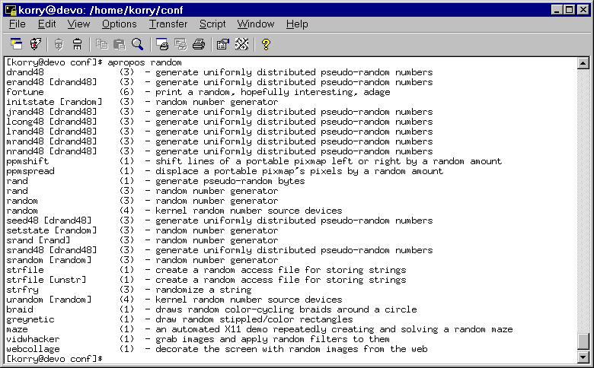
The Unix/Linux man pages are divided into sections. User commands are listed in section 1. API functions are listed in sections 2 and 3, so we can ignore most of the entries above.

Let's choose the random() function from section 3. You can view the manual page for this function by using the command: $ man 3 random

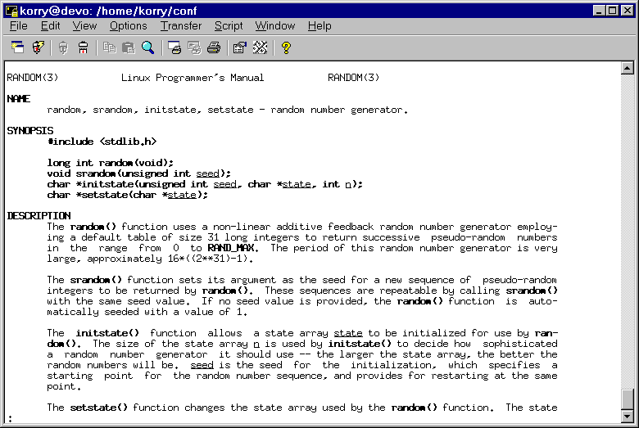
The documentation for this function tells us most of what we need to know to call this function from within Appx. Most importantly, we can see the data types required.

Here is a table showing the most commonly encountered data types and how they correspond to Appx data types:
Int | S9(10), binary
Short | S9(5), binary, GE –32768 and LE 32767
Char | S9(3), binary, GE –128 and LE 127
long int | Same as int
unsigned int | 9(10),binary
unsigned short | 9(5), binary, GE 0 and LE 65535
unsigned char | 9(3), binary, GE 0 and LE 255
pointer (*) | S9(10), binary
Void | no arguments, no return values

So, you can see that the srandom() function requires an unsigned int as it's only argument, and since it returns a void, it won't give us back anything meaningful.

The random() function doesn't expect any function arguments and returns us a long int. The return value from a function always comes back in the --- RETURN CODE PDF.

If you are going to call a C function from within your application, I recommend building a set of Domains for the commonly used data types. You might create data types named "INT", "CHAR", "POINTER", etc..

At this point, you know which function you want to call, the argument list for the function, and the type of return value.

The next step is finding the function. In Linux (and Unix) systems, most API functions are contained in a shared library - Appx can only CALL functions that exist in a shared library (unless you relink the engine). Most shared libraries exist in the /lib or /usr/lib directories. If you are trying to CALL a function defined in a vendor supplied library (such as Oracle or Sybase), consult the vendor's documentation.

Finding the correct library involves a bit of detective work. There are a few tricks that make the task easier. First, notice that the man page for this function starts with "#include <stdlib.h>". That's a pretty good clue that this function is part of the standard C runtime library. If the man page had started with "#include <math.h>", the function would probably exist in the math library. So, looking at the man page gives you a clue about which package the function belongs to, but how do you find the actual library name?

Most of the standard Unix commands (such as ls, cat, bash, etc.) are written in C and linked against the standard C runtime library. Using the ldd command, you find the names of the shared libraries that a given program is linked to:

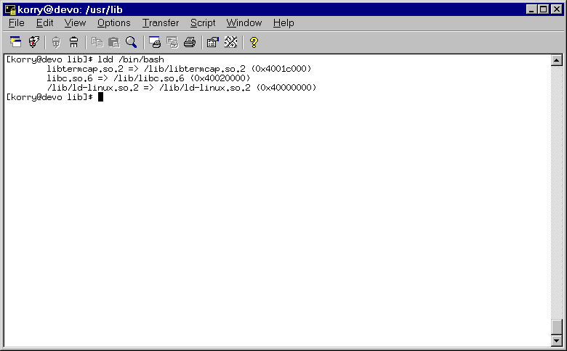
You can see that the /bin/bash program is linked against three shared libraries:
/lib/libtermcap.so.2
/lib/libc.so.6
/lib/ld-linux.so.2

One of these is probably the C runtime library – you can guess that it is /lib/libc.so.6. We can now use the nm command to get a list of the functions exported by this library:

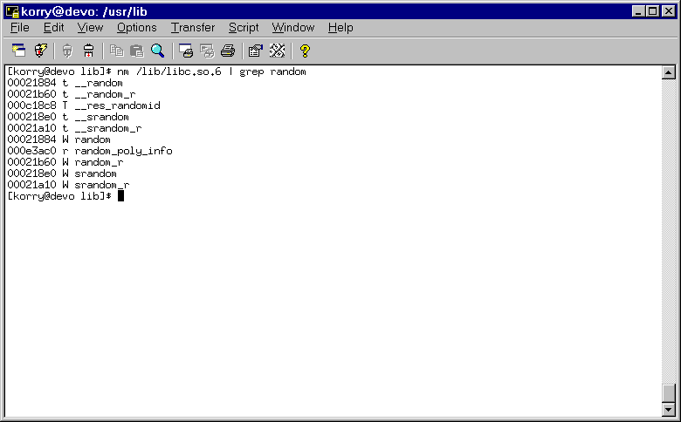
The /lib/libc.so.6 library does indeed include a function named random(), let's call that function from within an Appx process. Here is a simple subroutine that will return a random number between 0 and 9 (inclusive).

GET RANDOM NUMBER (Subroutine)
RECEIVE --- RI FIELD FAIL N
*
CALL /lib/libc.so.6,random RESIDENT? N END? N FAIL 0
SET --- RI = --- RETURN CODE
CALC RI = @MOD(RI,10)

You can see that this function RECEIVE's a single parameter – a numeric field. When you call this function, you should PASS (shared) a single numeric field and GET RANDOM NUMBER will return a value into that field:

PASS KAD PRES KEY FIELD SHARE? Y
GOSUB GET RANDOM NUMBER

Finding the right function – Windows

Now let's see how to find and CALL a function on a Windows host. This time around, we'll tackle a slightly large problem. We want to download an HTML file, from a Web server, into an Appx application.

The WIN32 API provides a set of functions that we can use to deal with the Internet. You can find Windows API documentation at http://msdn.microsoft.com. Here is the manual entry for the InternetOpen() function:

InternetOpen Function

--------------------------------------------------------------------------------

Initializes an application's use of the Microsoft® Win32® Internet functions.

Syntax

HINTERNET InternetOpen(
IN LPCTSTR lpszAgent,
IN DWORD dwAccessType,
IN LPCTSTR lpszProxyName,
IN LPCTSTR lpszProxyBypass,
IN DWORD dwFlags
);

The actual syntax of this function varies between its ANSI and Unicode implementations. For more information, see Win32 Internet Functions Syntax.

Parameters

lpszAgent
Address of a string variable that contains the name of the application or entity calling the Internet functions (for example, Microsoft® Internet Explorer). This name is used as the user agent in the HTTP protocol.

dwAccessType
Type of access required. This can be one of the following values:
INTERNET_OPEN_TYPE_DIRECT
Resolves all host names locally.
INTERNET_OPEN_TYPE_PRECONFIG
Retrieves the proxy or direct configuration from the registry.
INTERNET_OPEN_TYPE_PRECONFIG_WITH_NO_AUTOPROXY
Retrieves the proxy or direct configuration from the registry and prevents the use of a startup Microsoft® JScript® (compatible with ECMA 262 language specification) or Internet Setup (INS) file.
INTERNET_OPEN_TYPE_PROXY
Passes requests to the proxy unless a proxy bypass list is supplied and the name to be resolved bypasses the proxy. In this case, the function uses INTERNET_OPEN_TYPE_DIRECT.
lpszProxyName
Address of a string variable that contains the name of the proxy server(s) to use when proxy access is specified by setting dwAccessType to INTERNET_OPEN_TYPE_PROXY. Do not use an empty string, because InternetOpen will use it as the proxy name. The Win32 Internet functions recognize only CERN type proxies (HTTP only) and the TIS FTP gateway (FTP only). If Internet Explorer is installed, the Win32 Internet functions also support SOCKS proxies. FTP and Gopher requests can be made through a CERN type proxy either by changing them to an HTTP request or by using InternetOpenUrl. If dwAccessType is not set to INTERNET_OPEN_TYPE_PROXY, this parameter is ignored and should be set to NULL. For more information about listing proxy servers, see the Listing Proxy Servers section of Enabling Internet Functionality.

lpszProxyBypass
Address of a string variable that contains an optional list of host names or IP addresses, or both, that should not be routed through the proxy when dwAccessType is set to INTERNET_OPEN_TYPE_PROXY. The list can contain wildcards. Do not use an empty string, because InternetOpen will use it as the proxy bypass list. If this parameter specifies the "<local>" macro as the only entry, the function bypasses any host name that does not contain a period. If dwAccessType is not set to INTERNET_OPEN_TYPE_PROXY, this parameter is ignored and should be set to NULL.
dwFlags
Unsigned long integer value that contains the flags that indicate various options affecting the behavior of the function. This can be a combination of these values:
INTERNET_FLAG_ASYNC
INTERNET_FLAG_FROM_CACHE
INTERNET_FLAG_OFFLINE
Return Value

Returns a valid handle that the application passes to subsequent Win32 Internet functions. If InternetOpen fails, it returns NULL. To retrieve a specific error message, call GetLastError.

Remarks

InternetOpen is the first Win32 Internet function called by an application. It tells the Internet DLL to initialize internal data structures and prepare for future calls from the application. When the application finishes using the Internet functions, it should call InternetCloseHandle to free the handle and any associated resources.

The application can make any number of calls to InternetOpen, though a single call is normally sufficient. The application might need to define separate behaviors for each InternetOpen instance, such as different proxy servers configured for each.

After the calling application has finished using the HINTERNET handle returned by InternetOpen, it must be closed using the InternetCloseHandle function.

Function Information

Windows NT Use version 4.0. Implemented as ANSI and Unicode functions.
Windows Use Windows 95 and later. Implemented as ANSI and Unicode functions.
Header Wininet.h
Import library Wininet.lib
Minimum availability Internet Explorer 3.0 (ANSI only), 5 (ANSI and Unicode)

Windows CE

Windows CE Use version 2.12 and later. Implemented as ANSI and Unicode functions.
Minimum availability Internet Explorer 4.0

See Also

Microsoft Win32 Internet Functions Overview, Enabling Internet Functionality, Microsoft Win32 Internet Functions Reference, General Win32 Internet Functions

Finding the correct library is pretty easy in the Windows environment – the information you need you need is right there in the documentation:
Import library Wininet.lib
We will actually find the InternetOpen() function in Wininet.dll. But, there is one more wrinkle here – Wininet.dll actually contains two copies of InternetOpen() – an ASCII version and a Unicode (or wide-character) version. You can use the Quickview program to view the function names within a DLL:

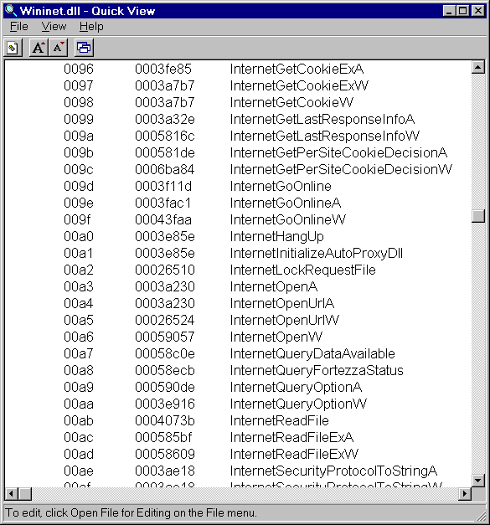

You can see from the manual entry that this function requires five parameters (lpszAgent, dwAccessType, lpszProxyName, lpszProxyBypass, and dwFlags ).

Microsoft uses an unusual naming convention, here is a quick explanation:

lp means that the function is expecting a pointer to something

lpsz means that you should PASS a pointer to a NULL-terminated string (I'll show you how to do that in a moment).

dw means that you should PASS a double-word (also known an integer)

lpdw would mean that you should PASS a pointer to a double-word

When we call this function, we will only provide a real value for the first parameter (lpszAgent) – for the remaining parameters, we want to use the default behavior and will PASS zero or NULL as appropriate.

This function returns a handle. A handle is just an integer that we get from the API and that we give back to the API whenever we want to do something useful. In this example, we'll open an Internet handle (an HINTERNET) and we'll give that handle back to Windows when we want to open a URL. When we open a URL, we get back a second handle. We'll give the second handle to the InternetReadFile() function and it will read the content associated with that handle into an Appx field.

Most of the C API's work with NULL-terminated strings. To make one of these, we just APPEND a null-byte (a character with the value 0) to the end of an Appx alpha field. I'll define a subroutine a little later that will do the work for us.

Before we go much further, let's define a few domains and work fields that we'll find handy.
I'll define three domains:

POINTER | Numeric, 9(10), binary
INT | Numeric, 9(10),binary
FUNCTION NAME | Alpha, X(60), lower-case allowed

And I'll define the following work fields:

Work Field Name | Domain | Default Value
ZERO | INT | 0
NULL | POINTER | 0
*INTERNETOPEN | FUNCTION NAME | Wininet.dll,InternetOpenA
*INTERNETOPENURL | FUNCTION NAME | Wininet.dll,InternetOpenUrlA
*INTERNETREADFILE | FUNCTION NAME | Wininet.dll,InternetReadFileA
WORK HTML TEXT | TEXT X(1920)

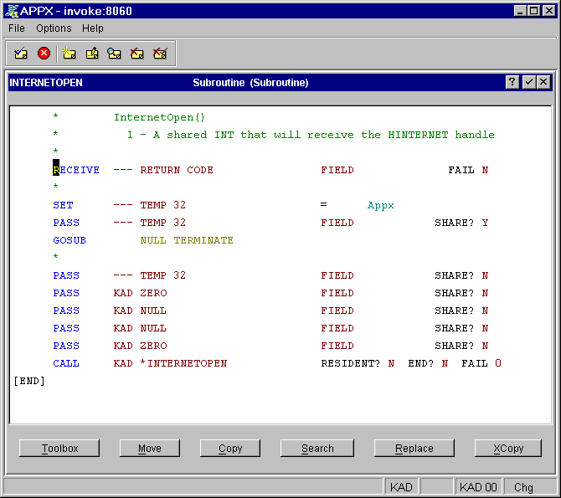
Now, we can define a few subroutines to call the required functions. First, we will need a subroutine to call the InternetOpen() function:

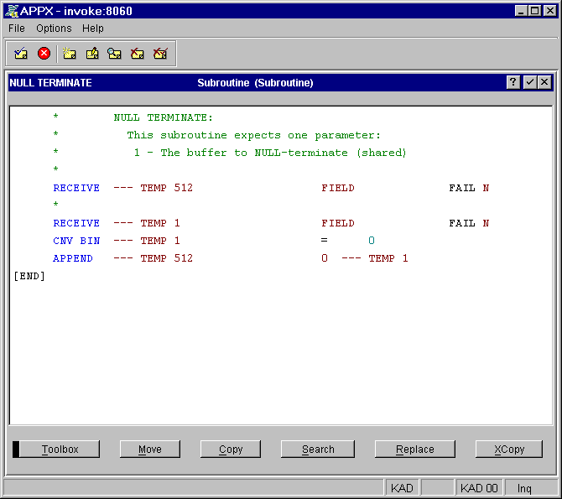
You can see that I am calling a subroutine named NULL TERMINATE – let's look at that one next:
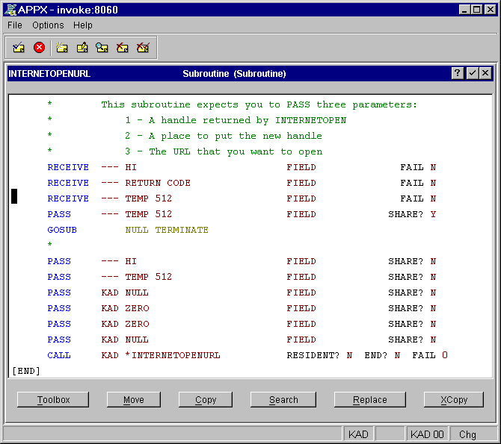
Now let's look at the next function – this one will receive a URL, open it, and return a handle that can be used to retrieve the contents of the URL:

Next, here is the subroutine that reads the contents of a URL into a field:
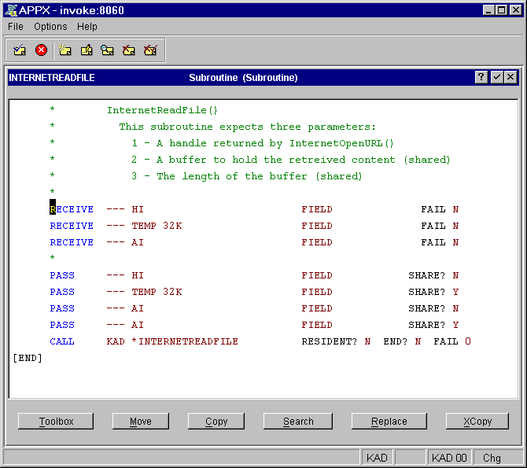
Finally, here is the subroutine that ties all this together. You pass two parameters to this subroutine: the URL that you want to read, and a buffer to hold the content (shared):

