Interfacing Appx with the PostgreSQL OpenSource RDBMS

Beginning with release 4.1.8, Appx includes support for interacting with ODBC databases under Unix./Linux. The Linux engine will dynamically link with unixODBC or iODBC starting with release 4.1.8. All other Unix engines support unixODBC and/or iODBC starting with release 4.1.a.

To use Appx and ODBC together under Unix/Linux, you will need to install the following components:

- Appx
- A driver manager (unixODBC or iODBC)
- A database driver
- A relational database

The driver manager is responsible for loading the correct driver – that’s pretty much all it does. We recommend using unixODBC (www.odbc.org), but we have also done some experimentation with iODBC.

The database driver that you choose must be compatible with the version of Unix you are running, and of course it must be a driver that works with your database.

In the following document, I’ll show you how to configure the unixODBC driver manager to work with the PostgreSQL open-source database. You can follow a similar procedure to interface with MySQL and mSQL.

I’ll assume that you already have Appx, and PostgreSQL installed and running on your system. I’ll show you how to build and install the unixODBC driver manager, and then how to connect all of the pieces together.

Building and Installing the unixODBC driver manager

The unixODBC driver manager is distributed in source form – you can probably find pre-built binaries on the web for most platforms, but building the binaries yourself isn’t too difficult. You must have a C compiler on your system in order to build the driver manager (the open-source GNU CC compiler will work just fine).

After unpacking the unixODBC archive, log in as the super-user (root) and move into the unixODBC directory. Execute the following commands:

# ./configure
...
# make
...
# make install
...

I don’t want to mislead you here, the steps shown as “...” will take a considerable amount of time to execute, but unless something goes wrong, you shouldn’t have any trouble building unixODBC from source.

The first step (./configure) will examine your operating environment and adjust the source code accordingly. configure will test out your C compiler to determine which features are supported, it will try to guess at what flavor of Unix you are using, etc..

The next step (make) will take quite a while. It could take as little as five minutes, or as long as a few hours depending on your system. When this step has completed, you will have built all of the executables for unixODBC, but they won’t be moved into the correct directories yet.

The final step (make install) will move all of the files into the correct locations for your system. By default, most of the executables will be placed in the /usr/local/bin directory and the configuration files will be placed in /etc.

Creating a PostgreSQL data source

Once you have unixODBC built and installed on your system, it’s time to create a data source. If you have used the ODBC system on a Windows host, this step will be very familiar.

A data source is a named collection of properties that describes a database. When an ODBC client application (such as Appx or Crystal Reports) wants to connect to an ODBC database, it does so using the data source name.

The unixODBC package comes with a nice GUI tool that makes it easy to create data sources. To run this ODBC configuration tool, execute the following command:

# ODBCConfig

The first you’ll see is the following window:

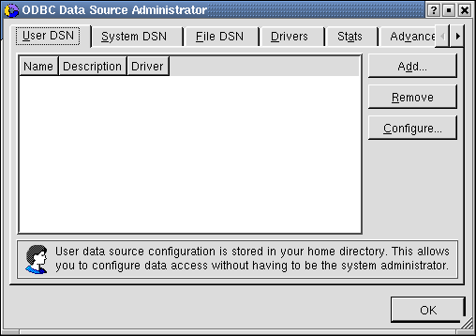

You can see from the tabs at the top of the window that unixODBC supports three types of data sources (or DSN’s): User DSN’s, System DSN’s, and File DSN’s. We’ll only worry about System DSN’s for now.

Before you can create a data source, you must register a driver. unixODBC comes with a PostgreSQL driver. Move to the Drivers tab and press the Add button:

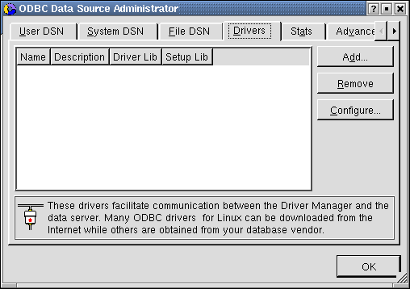

The following window will appear. Go ahead and enter the data that I’ve shown in this example. When you are finished, click on the check-mark in the upper-left-hand corner of the window.
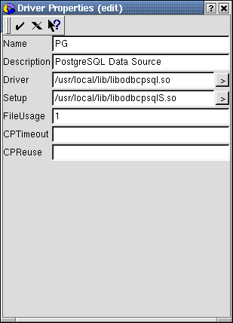

In this window, we are providing unixODBC with a name for the driver (PG), a user-friendly description (PostgreSQL Data Source), and the two code-libraries that comprise the driver itself (libodbcpsql.so and libodbcpsqlS.so).
Now we can define a data source. Click on the System DSN tab and press the Add button. From this screen, select the PG driver and click Ok. Don’t click Add on this screen – unixODBC will think that you want to add a new driver.

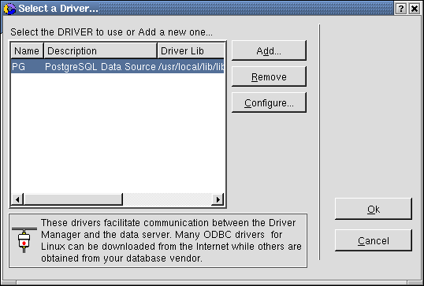

The following window will appear. In this window, you are defining the set of properties that will be known as the PG data source. You can leave most of these properties set to their default values. You must enter the Name, Description, and Database. If you are using a database other than PostgreSQL, the data source properties window will ask for a different set of specifications. Click on the check mark when you are finished:
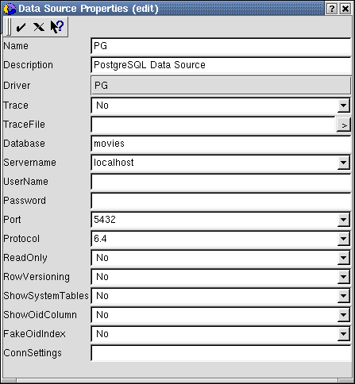
At this point, you should make sure that your PostgreSQL database is up and running. I’ll use the following commands to start PostgreSQL:
# su postgres
$ pg_ctl start –D /var/lib/pgsql/data

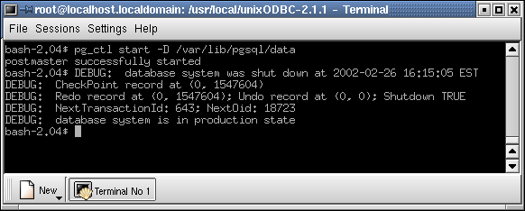

I’ll also use the PostgreSQL createuser command so that PostgreSQL will allow users appx and root to log in:

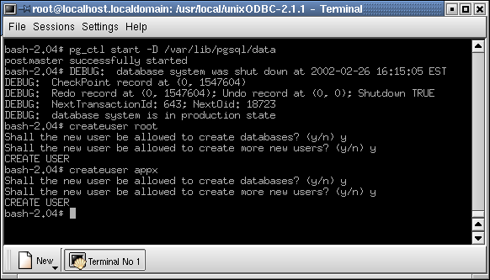
At this point, you should be able to connect to your PostgreSQL database using an ODBC client application. unixODBC ships with a nice tool called DataManager:

$ DataManager

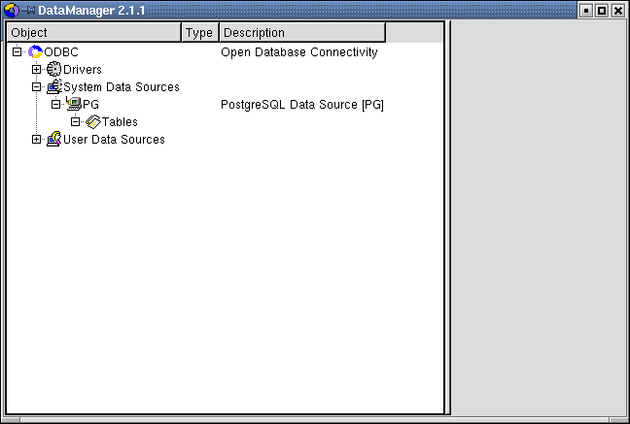

Now it’s time to connect Appx to this same data source. The first thing you have to do is to tell Appx where you installed the unixODBC driver manager. The APPX_ODBC_LIB environment variable will tell Appx how to find unixODBC (or iODBC):

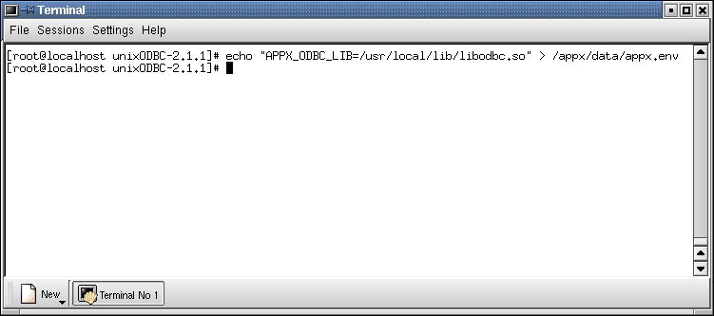
Now fire up your copy of Appx and navigate to System Administration, Configuration, File System Groups. We are going to define a new FMS group called PostgreSQL – it must be a type 6 FMS group.

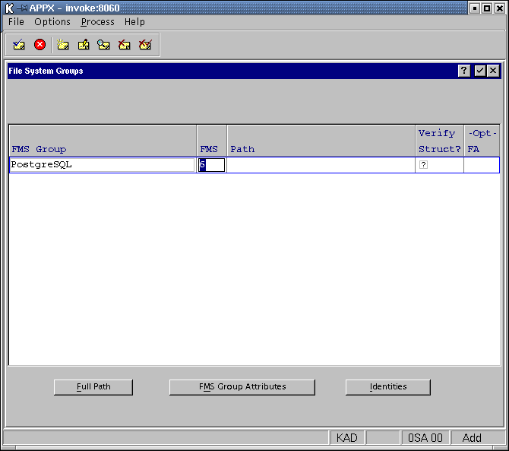

Fill in the FMS Group options as follows (note that you can SCAN for the Data Source Name:
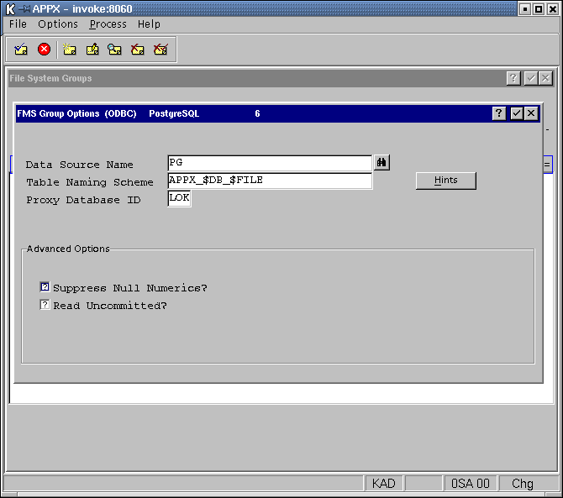

The Table Naming Scheme tells Appx how to translate an application ID, database ID, and 8-character filename into a PostgreSQL table name. You can press the Hints button to see some pre-defined choices. The Proxy Database ID is required when using PostgreSQL – this database provides a place for Appx to do row-level locking (most RDBMS’s don’t do row-level locking). Choose a database ID that you are NOT using for any other purpose.

Once you have completed the FMS Group Options screen, you will need to define an identity. When Appx connects to a relational database, it must provide a username and (an optional) password. When you associate an identity with an FMS group, you are telling Appx to use a specific user id (and password) when connecting to that FMS. You can define per-user (per-FMS) identities as well as a default identity. In the example below, we are creating a default identity (the Appx user name is blank) and telling Appx to connect to this FMS group as user root.

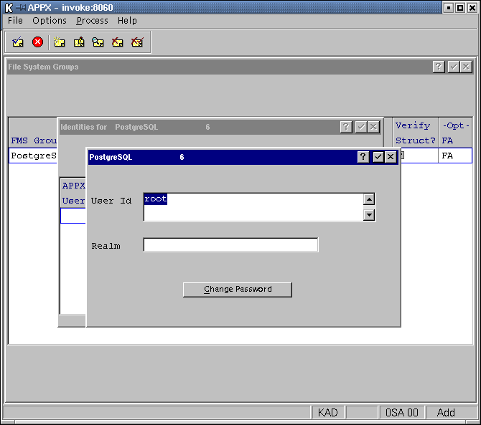
At this point, Appx should be able to interact with your PostgreSQL database. Let’s move some of the DMO/DMO data files from AppxIO format to our new PostgreSQL database. Navigate to Database Management, select Datbase DMO and Application DMO, select All data files, and then export them.

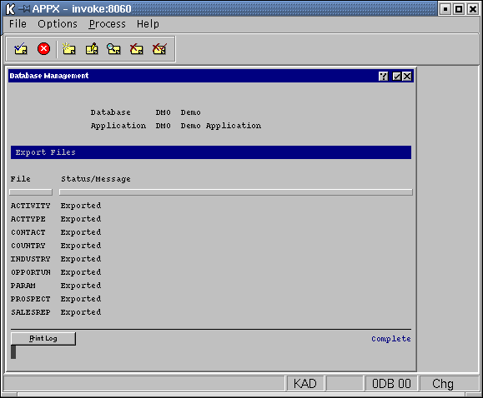

Now we’ll select just a few files from DMO/DMO and move them into our PostgreSQL FMS group. Select the first four files, navigate to File Specifications, then change the FMS Types to 6 and the FMS Groups to PostgreSQL. Then, run Create Files, and finally Import them.
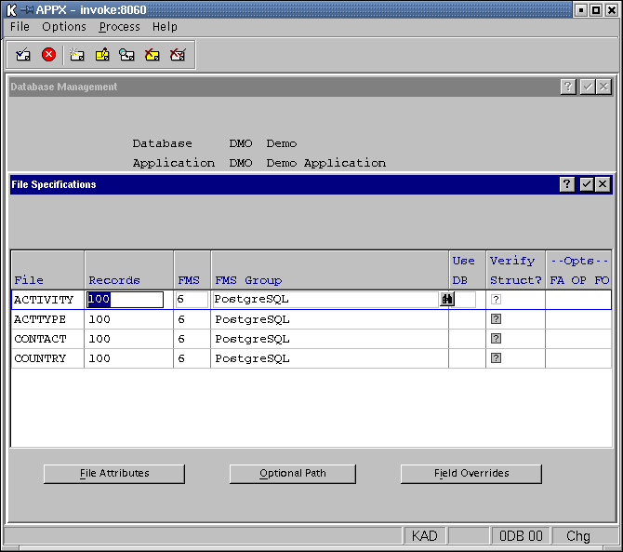

That’s it. You now have four files stored in your PostgreSQL database. You can use the DataManager client application (or any other ODBC client application) to view and modify your data. 